**Week 4**

**Hands-On Exercise: Spring REST using Spring Boot 3**

**Exercise 1: Create a Spring Web Project using Maven**:

* Visit <https://start.spring.io/>
* Change Group as “com.cognizant”
* Change Artifact Id as “spring-learn”
* Select Spring Boot DevTools and Spring Web
* Download the project zip file
* Open Eclipse and open the existing maven project
* Click “Run as Java Application” on the SpringLearnApplication

**Output:**

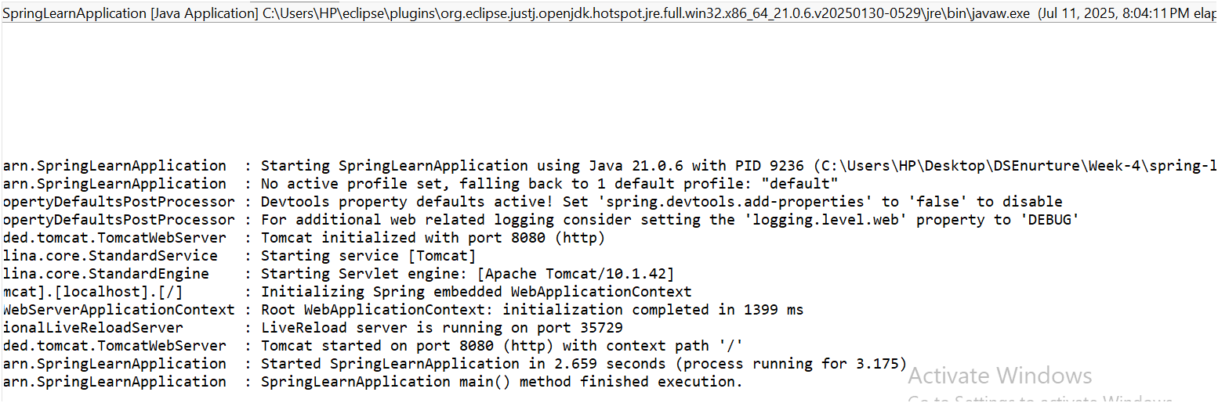

**Exercise 2: Spring Core – Load Country from Spring Configuration XML**

**Scenario:** SimpleDateFormat with the pattern 'dd/MM/yyyy' is created in multiple places of an application. To avoid creation of SimpleDateFormat in multiple places, define a bean in Spring XML Configuration file and retrieve the date.

**Country-config.xml:**

<?xml version=*"1.0"* encoding=*"UTF-8"*?>

<beans xmlns=*"http://www.springframework.org/schema/beans"*

xmlns:xsi=*"http://www.w3.org/2001/XMLSchema-instance"*

xsi:schemaLocation=*"http://www.springframework.org/schema/beans*

*https://www.springframework.org/schema/beans/spring-beans.xsd"*>

<bean id=*"in"* class=*"com.cognizant.spring_learn.model.Country"*>

<property name=*"code"* value=*"IN"*/>

<property name=*"name"* value=*"India"*/>

</bean>

<bean id=*"us"* class=*"com.cognizant.spring_learn.model.Country"*>

<property name=*"code"* value=*"US"*/>

<property name=*"name"* value=*"United States"*/>

</bean>

</beans>

**SpringLearnJava.java:**

**package** com.cognizant.spring_learn;

**import** org.springframework.boot.SpringApplication;

**import** org.springframework.boot.autoconfigure.SpringBootApplication;

**import** org.slf4j.Logger;

**import** org.slf4j.LoggerFactory;

**import** org.springframework.context.ApplicationContext;

**import** org.springframework.context.support.ClassPathXmlApplicationContext;

**import** com.cognizant.spring_learn.model.Country;

@SpringBootApplication

**public** **class** SpringLearnApplication {

**private** **static** **final** Logger ***LOGGER*** = LoggerFactory.*getLogger*(SpringLearnApplication.**class**);

**public** **static** **void** main(String[] args) {

SpringApplication.*run*(SpringLearnApplication.**class**, args);

***LOGGER***.info("SpringLearnApplication main() method finished execution.");

*displayCountry*();

}

**public** **static** **void** displayCountry() {

***LOGGER***.info("Starting displayCountry() method...");

ApplicationContext context = **new** ClassPathXmlApplicationContext("country-config.xml");

***LOGGER***.info("Loaded country-config.xml context.");

Country country = context.getBean("in", Country.**class**);

***LOGGER***.info("Retrieved 'in' country bean from context: {}", country);

System.***out***.println("Country Code: " + country.getCode());

System.***out***.println("Country Name: " + country.getName());

((ClassPathXmlApplicationContext) context).close();

***LOGGER***.info("Closed country-config.xml context.");

***LOGGER***.info("displayCountry() method finished.");

}

}

**Output:**

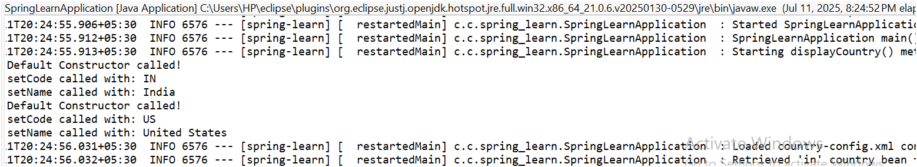

**Exercise 3: Hello World RESTful Web Service:**

**Scenario:** You need to create a simple RESTful web service endpoint that returns a "Hello World!" message.

* We create a new package in src/main/java/com/cognizant/springlearn/controller.
* Create a new java file HelloController.java

**HelloController.java:**

**package** com.cognizant.springlearn.controller;

**import** org.springframework.web.bind.annotation.GetMapping;

**import** org.springframework.web.bind.annotation.RestController;

**import** org.slf4j.Logger;

**import** org.slf4j.LoggerFactory;

@RestController

**public** **class** HelloController {

**private** **static** **final** Logger ***LOGGER*** = LoggerFactory.*getLogger*(HelloController.**class**);

@GetMapping("/hello")

**public** String sayHello() {

***LOGGER***.info("START - sayHello() method");

String message = "Hello World!";

***LOGGER***.info("END - sayHello() method. Returning: {}", message);

**return** message;

}

}

* Update the port number in application.properties(server.port=8083)
* Output runs in the http://localhost:8083/hello

**Output:**

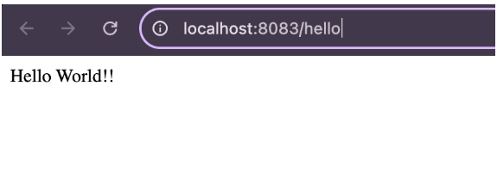

**Exercise 4: REST - Country Web Service:**

**Scenario:** You need to create a RESTful web service endpoint that returns a Country object

**Country-config.xml:**

<?xml version=*"1.0"* encoding=*"UTF-8"*?>

<beans xmlns=*"http://www.springframework.org/schema/beans"*

xmlns:xsi=*"http://www.w3.org/2001/XMLSchema-instance"*

xsi:schemaLocation=*"http://www.springframework.org/schema/beans*

*https://www.springframework.org/schema/beans/spring-beans.xsd"*>

<bean id=*"in"* class=*"com.cognizant.springlearn.model.Country"*>

<property name=*"code"* value=*"IN"*/>

<property name=*"name"* value=*"India"*/>

</bean>

<bean id=*"us"* class=*"com.cognizant.springlearn.model.Country"*>

<property name=*"code"* value=*"US"*/>

<property name=*"name"* value=*"United States"*/>

</bean>

</beans>

**Country.java:**

**package** com.cognizant.springlearn.model;

**public** **class** Country {

**private** String code;

**private** String name;

**public** Country() {

System.***out***.println("Inside Country Constructor.");

}

**public** String getCode() {

System.***out***.println("Getting Code");

**return** code;

}

**public** **void** setCode(String code) {

System.***out***.println("Setting Code");

**this**.code = code;

}

**public** String getName() {

System.***out***.println("Getting Name");

**return** name;

}

**public** **void** setName(String name) {

System.***out***.println("Setting Name");

**this**.name = name;

}

@Override

**public** String toString() {

**return** "Country [code=" + code + ", name=" + name + "]";

}

}

**CountryController.java:**

**package** com.cognizant.spring_learn.controller;

**import** com.cognizant.spring_learn.model.Country;

**import** org.slf4j.Logger;

**import** org.slf4j.LoggerFactory;

**import** org.springframework.context.ApplicationContext;

**import** org.springframework.context.support.ClassPathXmlApplicationContext;

**import** org.springframework.web.bind.annotation.RequestMapping;

**import** org.springframework.web.bind.annotation.RestController;

@RestController

**public** **class** CountryController {

**private** **static** **final** Logger LOGGER = LoggerFactory.getLogger(CountryController.**class**);

@RequestMapping("/country")

**public** Country getCountryIndia() {

LOGGER.info("START getCountryIndia()");

ApplicationContext context = **new** ClassPathXmlApplicationContext("country.xml");

Country country = context.getBean("country", Country.**class**);

LOGGER.info("END getCountryIndia()");

**return** country;

}

}

**SpringLearnApplication.java:**

**package** com.cognizant.springlearn;

**import** org.springframework.boot.SpringApplication;

**import** org.springframework.boot.autoconfigure.SpringBootApplication;

@SpringBootApplication

**public** **class** SpringLearnApplication {

**public** **static** **void** main(String[] args) {

SpringApplication.run(SpringLearnApplication.**class**, args);

}

}

**Output:**

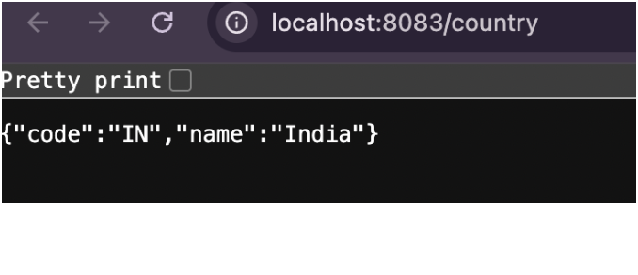

**Exercise 5 :REST - Get country based on country code:**

**Country-config.xml:**

<?xml version=*"1.0"* encoding=*"UTF-8"*?>

<beans xmlns=*"http://www.springframework.org/schema/beans"*

xmlns:xsi=*"http://www.w3.org/2001/XMLSchema-instance"*

xsi:schemaLocation=*"http://www.springframework.org/schema/beans*

*https://www.springframework.org/schema/beans/spring-beans.xsd"*>

<bean id=*"in"* class=*"com.cognizant.springlearn.model.Country"*>

<property name=*"code"* value=*"IN"*/>

<property name=*"name"* value=*"India"*/>

</bean>

<bean id=*"us"* class=*"com.cognizant.springlearn.model.Country"*>

<property name=*"code"* value=*"US"*/>

<property name=*"name"* value=*"United States"*/>

</bean>

</beans>

**CountryService.java:**

**package** com.cognizant.spring_learn.service;

**import** com.cognizant.spring_learn.model.Country;

**import** org.springframework.context.ApplicationContext;

**import** org.springframework.context.support.ClassPathXmlApplicationContext;

**import** org.springframework.stereotype.Service;

**import** java.util.List;

@Service

**public** **class** CountryService {

**public** Country getCountry(String code) {

ApplicationContext context = **new** ClassPathXmlApplicationContext("country.xml");

List<Country> countries = context.getBean("countryList", List.**class**);

**return** countries.stream().filter(c->c.getCode().equalsIgnoreCase(code)).findFirst().orElse(**null**);

}

}

**CountryController.java:**

**package** com.cognizant.springlearn.model;

**public** **class** Country {

**private** String code;

**private** String name;

**public** Country() {

System.***out***.println("Country: Default Constructor called!");

}

**public** Country(String code, String name) {

**this**.code = code;

**this**.name = name;

System.***out***.println("Country: Parameterized Constructor called! Code: " + code + ", Name: " + name);

}

**public** String getCode() {

**return** code;

}

**public** **void** setCode(String code) {

**this**.code = code;

System.***out***.println("Country: setCode called with: " + code);

}

**public** String getName() {

**return** name;

}

**public** **void** setName(String name) {

**this**.name = name;

System.***out***.println("Country: setName called with: " + name);

}

@Override

**public** String toString() {

**return** "Country [code=" + code + ", name=" + name + "]";

}

}

**Output:  
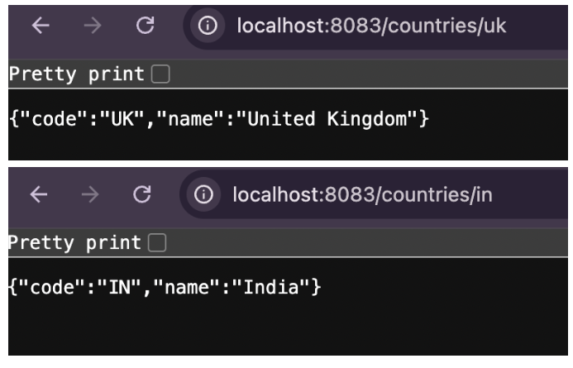**

**Exercise 6 : Create authentication service that returns JWT:**

**Pom.xml:**

<dependency>

<groupId>org.springframework.boot</groupId>

<artifactId>spring-boot-starter-security</artifactId>

</dependency>

<dependency>

<groupId>io.jsonwebtoken</groupId>

<artifactId>jjwt</artifactId>

<version>0.9.1</version>

</dependency>

**Jwtutil.java:**

package com.cognizant.spring_learn.util;

import io.jsonwebtoken.Jwts;

import io.jsonwebtoken.SignatureAlgorithm;

import org.springframework.stereotype.Component;

import java.util.Date;

*@Component*

public class JwtUtil {

   private final String SECRET_KEY = "mySecretKey123";

   public String generateToken(String username) {

       return Jwts.*builder*()

               .setSubject(username)

               .setIssuedAt(new Date(System.*currentTimeMillis*()))

               .setExpiration(new Date(System.*currentTimeMillis*() + 1000 * 60 * 10))

               .signWith(*SignatureAlgorithm*.***HS256***, SECRET_KEY)

               .compact();

   }

}

**AuthenticationController.java:**

**package** com.cognizant.spring_learn.controller;

**import** com.cognizant.spring_learn.util.JwtUtil;

**import** org.springframework.beans.factory.annotation.Autowired;

**import** org.springframework.http.ResponseEntity;

**import** java.util.Base64;

**import** org.springframework.web.bind.annotation.*;

**import** jakarta.servlet.http.HttpServletRequest;

@RestController

**public** **class** AuthenticationController {

@Autowired

**private** JwtUtil jwtUtil;

@RequestMapping(value = "/authenticate", method = RequestMethod.GET)

**public** ResponseEntity<?> authenticate(HttpServletRequest request) {

String authHeader = request.getHeader("Authorization");

**if** (authHeader != **null** && authHeader.startsWith("Basic ")) {

String base64Credentials = authHeader.substring("Basic ".length());

**byte**[] credDecoded = Base64.getDecoder().decode(base64Credentials);

String credentials = **new** String(credDecoded);

String[] values = credentials.split(":", 2);

String username = values[0];

String password = values[1];

**if** ("user".equals(username) && "pwd".equals(password)) {

String token = jwtUtil.generateToken(username);

**return** ResponseEntity.ok().body("{\"token\":\"" + token + "\"}");

} **else** {

**return** ResponseEntity.status(401).body("Invalid Credentials");

}

} **else** {

**return** ResponseEntity.badRequest().body("Missing Authorization Header");

}

}

}

**SecurityConfig.java:** **package** com.cognizant.spring_learn.config;

**import** org.springframework.context.annotation.Configuration;

**import** org.springframework.security.config.annotation.web.builders.HttpSecurity;

**import** org.springframework.security.web.SecurityFilterChain;

**import** org.springframework.context.annotation.Bean;

@Configuration

**public** **class** SecurityConfig {

@Bean

**public** SecurityFilterChain filterChain(HttpSecurity http) **throws** Exception {

http

.csrf(csrf -> csrf.disable())

.authorizeHttpRequests(auth -> auth

.requestMatchers("/authenticate").permitAll()

.anyRequest().authenticated()

);

**return** http.build();

}

}

**Output:**

